Coffee Cart Rewards Management System

User Manual

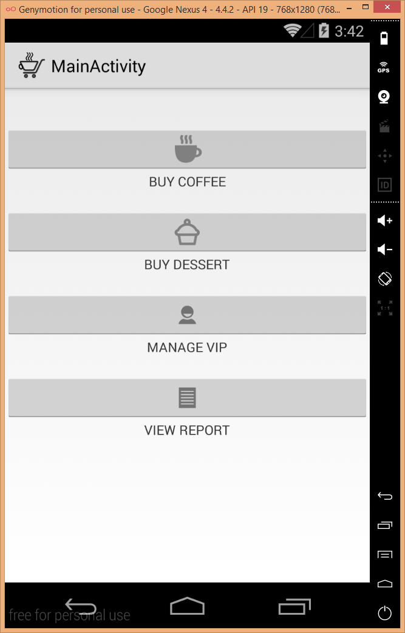

# Introduction

The Coffee Cart Rewards Management System will allow the owners of the LameDucks coffee shop to centrally manage a rewards system for their Customers across the numerous coffee carts they will have distributed around the city of Atlanta.

The goal of the system is to keep track of the total number of accumulated VIP points for every Customer. VIP points are earned through the purchases at any of the LameDucks coffee carts. Certain discounts will be automatically applied to any GOLD level Customer who has earned 5000 VIP points or more, or who has earned 500 points or more over the last 30 days.

The system will be constructed as an Android application that will run on a set of standardized devices that will be used by the Employees operating the coffee carts.

# Initial Setup

When the app is opened for the very first time, a selection or entry must be made for the coffee cart location where the app will be used. This will allow the Daily Reports to be generated correctly since this extra information is required to correctly attribute the Orders/Pre-Orders to a particular coffee cart.

# Basic Usage

After the initial setup has been completed, upon opening the app the Employees operating the coffee cart will have six basic functions they can access:

1. Manage Customers
2. Create an Order
3. View Today’s Orders
4. Create a Pre-Order
5. View Today’s Pre-Orders
6. Reports

Let’s go into more detail for each of these.

## Managing Customers

Within the Manage Customers area, the Employee will be able to View/Edit/Delete any of the existing Customers that have already been added into the system.

Additionally, the Employee will also have the ability to Add a New Customer, and assign them their unique VIP number along with the following customer provided information:

* Full Name,
* Phone Number
* Birth Date
* Address (Optional)

If the Delete option is chosen, the Employee will be prompted to confirm their selection since the Delete option will remove all of the Customer’s information and is not reversible.

## Creating an Order

Once an Employee starts the Create an Order process, the first thing they have to do is to select a Customer. This can be done via two methods:

1. Using the Customer’s VIP Number
2. Using the Customer’s Phone Number

Once the Customer has been selected, then one or more coffee and/or desserts can be added to the Customer’s order.

When ready to complete the order, the final total will be calculated automatically (along with any applicable GOLD level discounts) and the Order will be saved.

## View Today’s Orders

This screen allows the Employee to quickly review the Orders that have been created so far for the current day.

## Creating a Pre-Order

The Create a Pre-Order process is similar to the Create an Order one, however it is limited to dessert selections only and a date for when the Customer would like the dessert must be provided with each item selected.

Here are the steps the Employee must follow:

1. Select a Customer (as described in the Creating an Order section)
2. Select a Dessert
3. Select a Future Date
4. Complete the Pre-Order

After the Future Date is selected in Step 3, the system will check to make sure there still some remaining Pre-Order slots available for that day (if not, then the Pre-Order will not be able to be completed).

While Reports will be described in more detail in a subsequent section, the Pre-Order that gets created will allow the Employees and Owners to plan appropriately once the Future Date arrives so that the coffee cart will have enough inventory to meet the regular daily needs, along with those of the Pre-Orders.

When the Customer arrives on the Future Date, they should mention that they have a Pre-Order so the Employee can look them up using the View Today’s Pre-Orders screen, as described in the next section.

## View Today’s Pre-Orders

This screen allows the Employees to quickly see all of the day’s Pre-Orders.

When a Customer comes up and mentions that they have Pre-Ordered a dessert, the Employee can quickly look up the Pre-Order using this screen, and more importantly, quickly turn it into an Order (with the Customer and dessert already set).

At the end of the normal Order process is complete, the Order number will be attached to the Pre-Order and marked as “Fulfilled”. This will allow the owners to gain insight into how many of the Pre-Orders are actually being fulfilled and how many are never completed.

## Reports

The Reports will allow for a number of ad-hoc reports to be generated by the owners to gain insight into how their coffee carts are operating.

At a minimum it will allow for the following Reports to be generated:

1. Today’s Orders (For One or Multiple Locations)
2. Today’s Pre-Orders (For One or Multiple Locations)

Additional Reports are to be added in the future once the system is in place, however here is a quick list of planned Reports for the future:

1. General Orders Report (For One or Multiple Locations with Date Range Selection)
2. General Pre-Orders Report (For One or Multiple Locations with Date Range Selection)
3. Fulfilled vs. Unfulfilled Pre-Orders (For One or Multiple Locations with Date Range Selection)
4. Monthly/Yearly Summary Reports (For One or Multiple Locations with Date Range Selection)